Maths Quiz
Student’s Name
Course title
Date

Q1: Write a function involving x that does not have an inverse:
Solution
In order to get a function that doesn’t have an Inverse, the following function is used ;
f (x)= x²
For example
F(x) = (-2)²
This can be demonstrated as shown below;
Square: (−2)² = 4
Inverse (Square Root) : √(4) = 2
Q2. Find the inverse of the following one-to-one functions:

(a). 𝑓(𝑥) = 4𝑥 – 1
Solution
We first replace f(x) with y
Y=4x-1
Interchanging the variables
X=4y-1
Solve for y
4y−1=x
4y=x+1
Y=x/4+1/4
Solve for y and replace with f⁻¹(x)
f⁻¹ (x)=x/4+1/4
Q3: Graph the following functions,label the asymptote and two points:
- 𝑓(𝑥) = 4 𝑥+2 – 3
Solution
Exponential functions have a horizontal asymptote.The equation of the horizontal asymptote is y=-3.
The horizontal Asymptote; y=-3
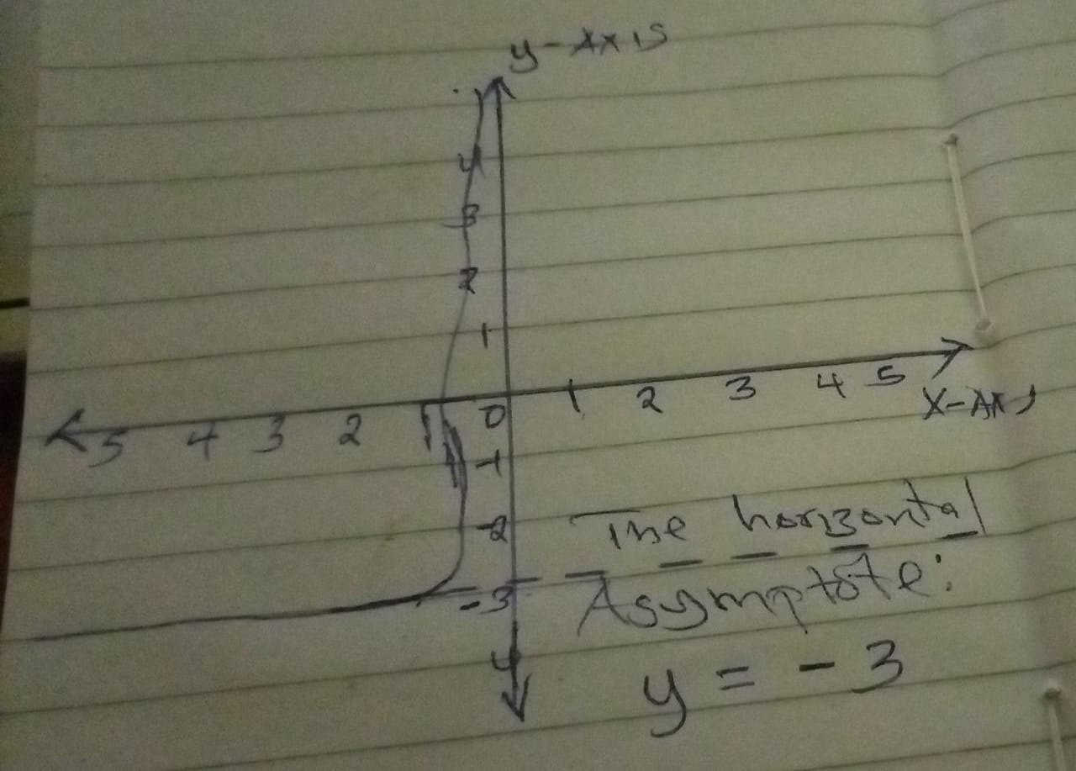

b.(𝑥) = −3 log(𝑥 − 2)
Solution
Graph the logarithm Uisng the vertical asymptote and a few selected points.
Vertical Asymptote;x=2

X y
3 0
4 -0.903
12 -3
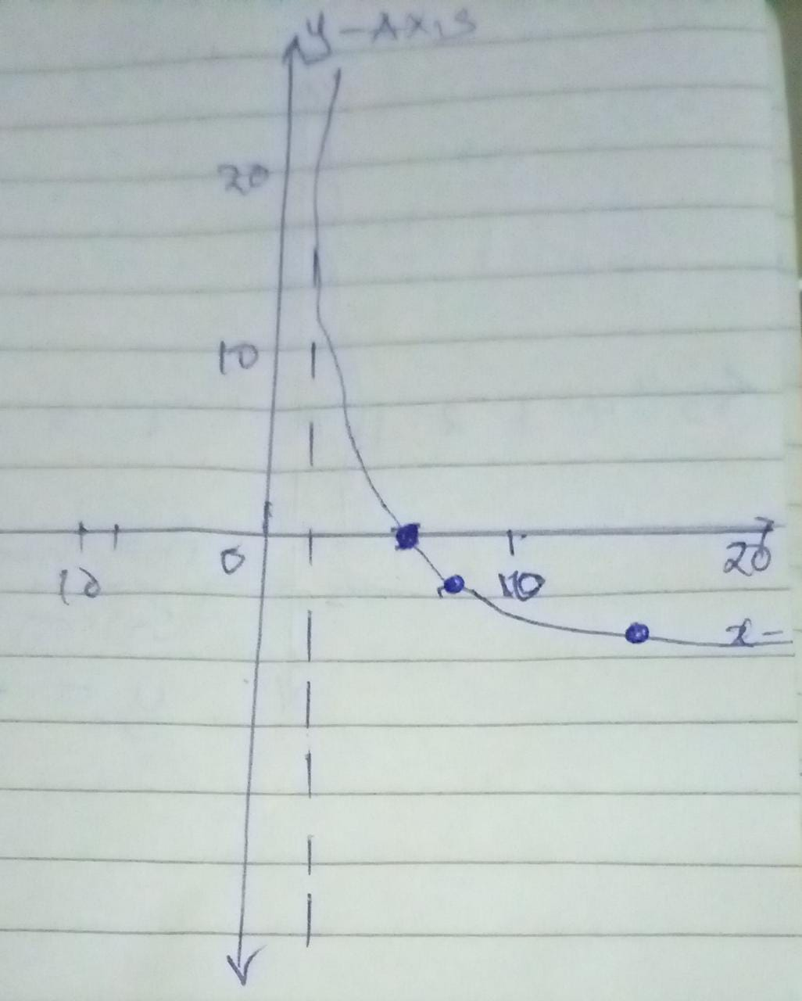

Q4: Solve the following logarithmic equation

log (3x+13)=2
Solution:
Simplifying

Log 3x+13)=2
= log (3x+13) =2
3x-13=10²
3x =100-13
3x=87
x=87/3
x=29
- Log₂ (3𝑥 − 2) = 4
Solution
= log₂ (3x-2) = 2⁴
3x-2 =2⁴
3x-2=16
3x=16+2
3x=18
x= 18/3
x=6
Q5. Solve the following logarithmic equation. 𝑙𝑜𝑔2 (2𝑥 − 1) + 𝑙𝑜𝑔2( 𝑥 + 3) = 2
Solution
𝑙𝑜𝑔2 (2𝑥 − 1) + 𝑙𝑜𝑔2 (𝑥 + 3) = 2
Log₂ (2x-1)(x+3) =2²
(2x-1)(x+3) =2²
2x² +5x−3 =4
2x²+5x-3-4=0
2x²+5x-7=0
X=1
Q6 Solve the following exponential equation. 27^{X-2} = 9^{X+1}
Solution
We first write the values to base 3
(3³)^{(x-2)} = (3²) ^{(x+1)}
3^{3x-6}=3^{2x+2}
We can now equate the exponents.
⇒3x-6=2x+2
3x-2x=6+2
X=8
Q7 Solve the following exponential equation. Give the exact answer and approximate your answer to two decimal places. 5^{2X-1} =4^{X+3}
Solution
5^{2X-1} =4^{X+3}
5^{2X}.5⁻¹ =4^{X}.4³
5^{2X}/5= 4^{X}.4³
5^{2X}/4^{X} =4³.5
(25/4)^{X} = 64X5
Taking log on both sides
Log (25/4)^{X} = log(64x5)
Log (AXB)= Log ( A)+log (B)

Log (A/B) = log (A)-log (B)

Therefore;
X (log (25)-log (4) = log (64)+log (5)
X=[log(64)+log(5)] / [log(25)-log (4)]
=2.505/0.795
=3.1474
X=3.15
Q 8.How long would it take an investment to double if at 5.3 % compounded continuously?
Solution
Let the investment be P
Let after t years Investment becomes 2P
Rate =5.3% = 0.053
For Compound Continuously
2P =P ^{e0.053t}
2=e^{0.053t}
Ln (2)/0.053 = t
t=13.08 years.

